|  |  |  |  |  |
| --- | --- | --- | --- | --- |
| Module 2 Workshop (Qualitative Risk Assessment Method) | | | | |
| GROUP NO: | | | | |
| s | s | s | s | s |
| s | s | s | s | s |

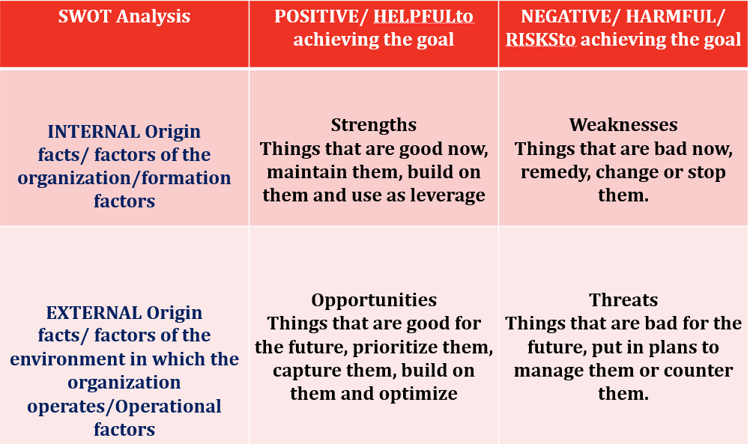

|  |
| --- |
| Strengths of DIA |
| 1 Automated baggage System |
| 2 Modernistic design and layout |
| 3 Ergonomically planned for the future |
| 4 room to grow |
| 5 Strong support from the city of Denver |
| 6 Strong support from the FAA |
| 7 |
| 8 |
| 9 |
| 10 |

|  |
| --- |
| Weakness of DIA |
| 1 Opening day is postponed |
| 2 Problems with fire security systems and inoperable baggage handling system |
| 3 Delayed a lot of times |
| 4 Highly leverage tenants |
| 5 Distance from the city |
| 6 High Operating costs |
| 7 High landing fees |
| 8 High passenger enplaning costs |
| 9 No industrial parks close to airport |
| 10 Potential lack of qualified labor problem because of driving distance from the city |

|  |
| --- |
| Opportunities of DIA |
| 1 Growth potential |
| 2 Create more jobs |
| 3 Sign agreements with more domestic cargo carriers |
| 4 Sign agreements with international cargo carriers |
| 5 Development of surrounding area (theme parks, industrial parks, casinos) |
| 6 New hub for other airlines such as northwest, USAir or Mark Air |
| 7 |
| 8 |
| 9 |
| 10 |

|  |
| --- |
| Threats of DIA |
| 1 Recession resulting in less passenger traffic |
| 2 Poor estimates of passenger traffic |
| 3 Larger than anticipated maintenance costs because of sinking buildings, cracking runways, |
| 4 Front range Airport becomes a major competitor |
| 5 Low cost carriers begin servicing Denver, thus forcing price wars. |
| 6 |
| 7 |
| 8 |
| 9 |
| 10 |